Command Pattern –
Behavioural pattern
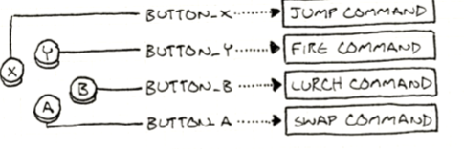
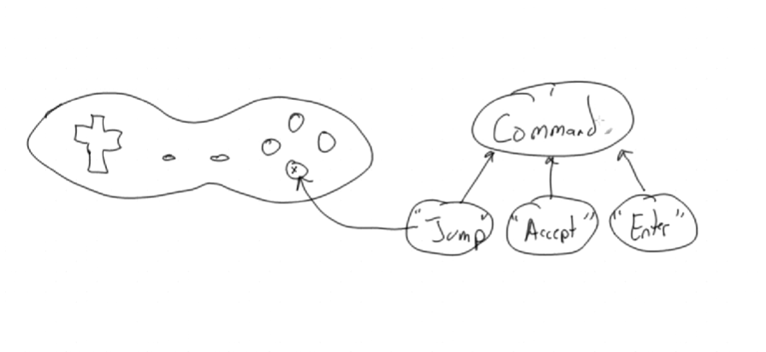
Singleton Pattern –
A creational Design pattern
Allows only one instance

Factory Pattern –
Creational Design Pattern
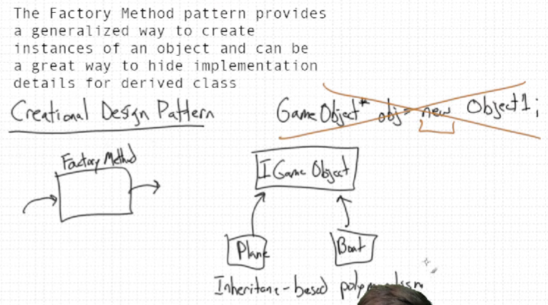
For Virtualization –
Why = 0 Matters
virtual void update() = 0;
means:
- this is a pure virtual function
- no implementation exists in base class
- derived classes MUST override it
This makes IGameObject an interface/abstract class.

Iterator Pattern -
It is a behavioural pattern
